**ORTHOGRAPH OPERATIONAL BIM – Digital Twin available for everyone**

**Operation based on real data, always at hand**

OrthoGraph is a leading-edge mobile and web ecosystem supporting the **rapid and accurate Digital Twin creation** of any existing building and then providing **integrated** **graphical access** to it. The **always** **up-to-date** Digital Twin contains in addition to the 3D model a professional, detailed and digitally controlled **asset inventory** too, let it be furniture, an HVAC item, a meter, a fuse box, or a medical device like a CT or MRI.

OrthoGraph Operational BIM provides an always fresh, clear view of the owned property including assets, that can easily be communicated with subcontractors in tenders or for designing purposes and is not only stored in the heads of the maintenance crew. As The model can be **integrated** with any CAFM, CMMS, IWMS or Building Management systems. It becomes part of the everyday facility management workflows.

Maintenance workers – even low-educated employees - can access and keep the building data up-to-date on-site by measuring the building (e.g. hospitals) only once and then staying in control by following all changes.

**ROI and other benefits**

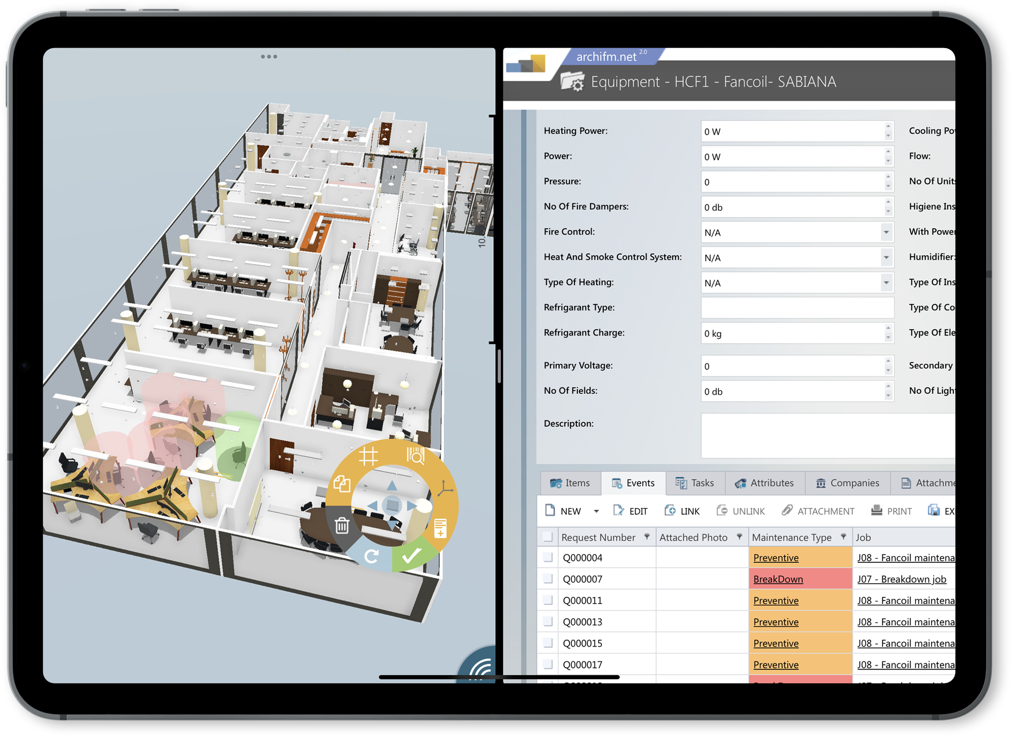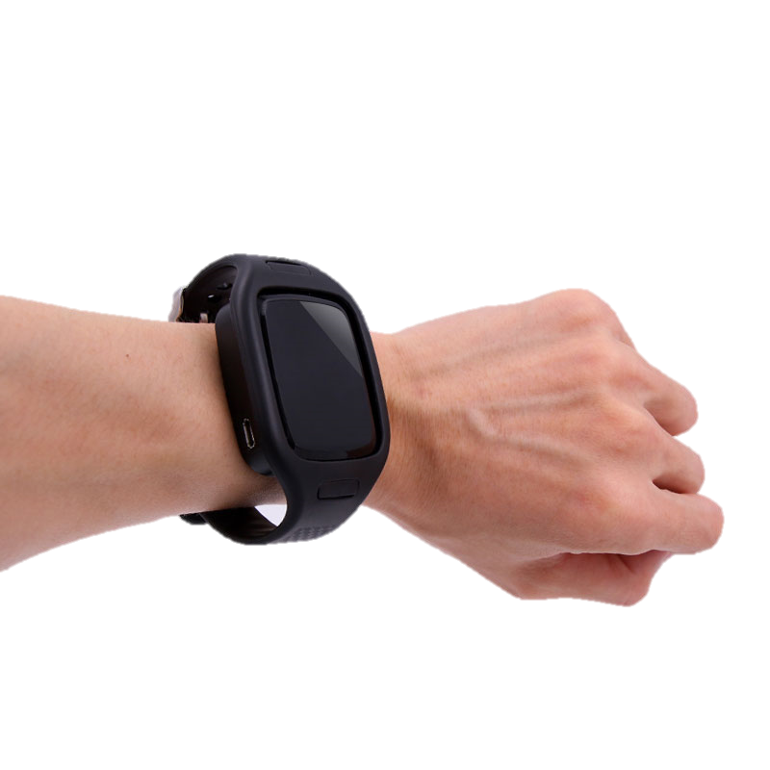

**Value proposition**

OrthoGraph enables a **10-20% cost reduction** over the full life cycle of the real estate while **improving operational quality**. The improved workflow efficiency is achieved through better planning and by providing the **exact location of assets** with related documentation. With OrthoGraph BIM is transformed into a real and available asset thus providing a tremendous saving potential in the FM portfolio.

**Economic return for healthcare institutions**

The maintenance of healthcare institutions is very expensive, which can be significantly reduced by using OG, and the difference can be used for the benefit of patients or for other improvements, which also generates an increase in income. <https://www.orthograph.com/operational-bim-in-hospitals-healthcare/>

**Pricing strategy**

<https://oglink.co/OGPricelistEUR>

**Reference**

In the case of Hungary's largest hospital university (Semmelweis University), we could achieve 51% / 65% energy cost savings on the lighting electricity costs by providing a clear, exact graphical inventory of the lighting fixtures, and the related floor plans. There then new lighting has been designed by the exact functionality of the given rooms providing an improved user experience while providing the above savings. The amount of savings was dependent on whether the given area got a smart or regular lighting fixture.

[https://www.orthograph.com/](https://www.orthograph.com/orthograph-operational-bim-in-semmelweis-university-top-ranking-medicine-and-health-sciences-university/)